Hooray! Your district purchased Choosi – an online meal pre-ordering tool that allows you to login and place a breakfast, lunch, snack, and/or supper order for the students in your classroom. Pre-ordering in Choosi is an easy way for you to communicate to your food service department the meals your students would like so they can safely and contactless-ly deliver meals directly to your classroom.
You can access your school’s breakfast & lunch menus by going to www.getchoosi.com and logging in.

Ordering is Easy!
- Click on the Sign In button on the top right-hand side of your screen
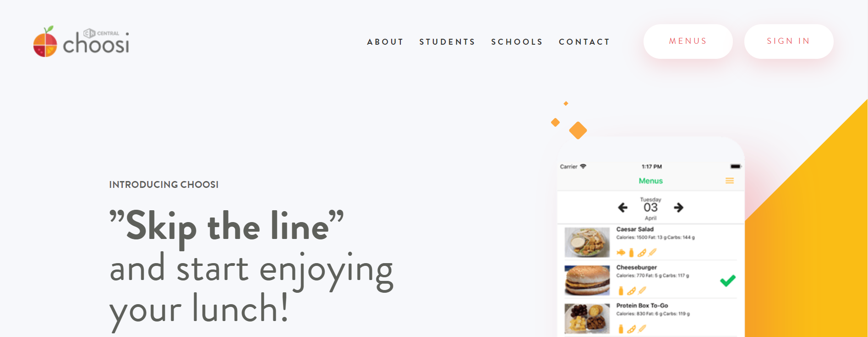

- You’ve already been setup with an account. Your username is your school issued email address and your temporary password is Choosi123 (case sensitive). Enter your credentials into the Username and Password fields and click the Sign In button.
Note: The first time you login, you’ll have to enter your temporary password, create a new one, and accept the terms and conditions.

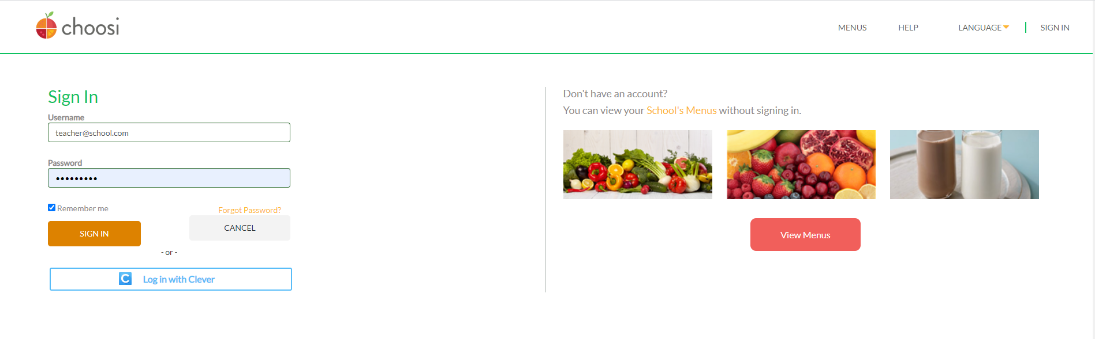

- By default, you’ll see the current days menus each time you login. If you need to switch the ordering day, click the arrows next to the calendar icon to scroll between days. Breakfast meals have a Breakfast tag to the left of the menu item name and lunch meals have a Lunch tag. You can see the entree name, description, and what’s included for each entrée available for pre-order.
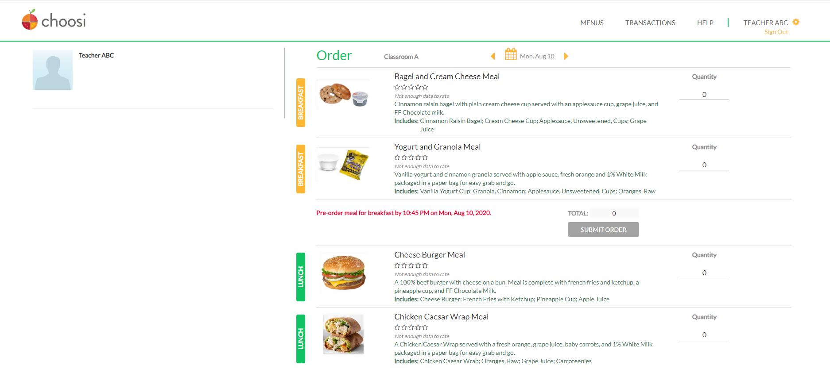
Scroll to a different day
View the entrée name, a description of the meal, and what’s included in it
View meal type
- Enter the total number of meals you’d like to order for each meal and meal session. Click the Submit Order button for each meal session.
Note: You’ll be asked to confirm the order and will see an order summary prior to the order being placed.
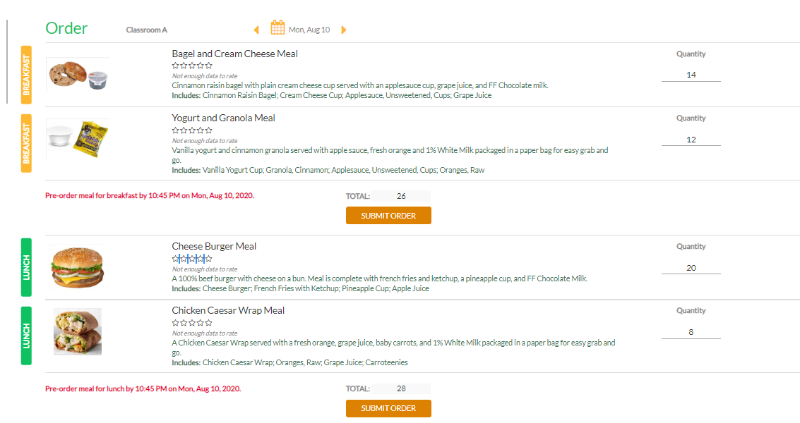
Make sure to place order before order cut-off time
Enter total number of meals to order for each meal listed
- Submitted orders are indicated by a check mark to the far right of each entrée displayed. If you need to cancel a placed order, you may do so but you will NOT be able to re-order for that meal session. You will need to contact your districts Food Service Department directly.
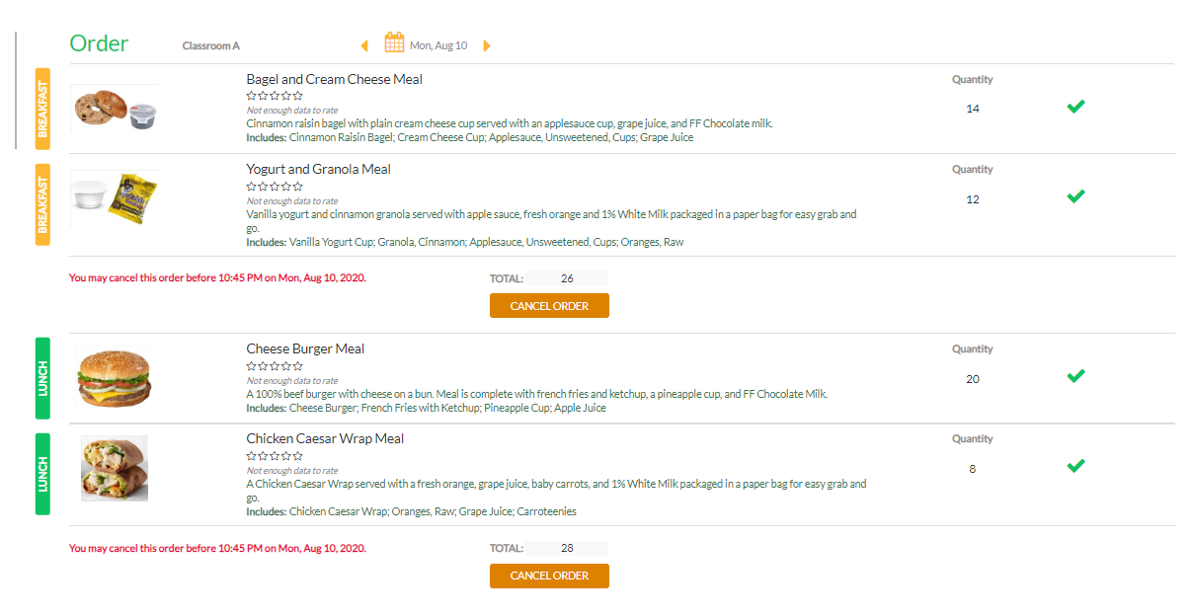
This will cancel your order but you will not be able to re-place your order. You’ll have to reach out to your district Food Service Dept.
Green check mark indicates an order has been placed
- If you need help using Choosi, you can click the help button and submit a ticket to our support team direct from within the website or you can email us at Support@GetChoosi.com.
